**Configuring IP Phones on a Local Network**

**Topology**

**PC Port**

**Fast Ethernet Port**

**Fast Ethernet Port**

**PC Port**

**PH 2**

**PH 1**

**R1**

**S1**

**Fe0/0**

**Fe0/48**

**Fe0/1**

**Switch Port**

**Fe0/2**

**Switch Port**

**PC-B**

**PC-A**

**Background**

Businesses use IP phones to allow voice calling between departments via their internal computer network. This lab will walk you through setting up a local network in which both IP phones and computers can communicate with each other.

**Equipment List**

* **1** Cisco 2811 Router
* **1** Cisco 2960 **or** 3560 series POE-48 Switch
* **2** Cisco 7945 IP Phones
* **2** PCs with RJ-45 ports
* **5** Lengths of straight through RJ-45 cable

**Addressing Table**

|  |  |  |  |  |
| --- | --- | --- | --- | --- |
| **Device** | **Interface** | **IP Address** | **Subnet Mask** | **Default Gateway** |
| **S1** | VLAN 10 (data) | 192.168.10.0 | 255.255.255.0 | N/A |
| **S1** | VLAN 20 (voice) | 192.168.20.0 | 255.255.255.0 | N/A |
| **S1** | VLAN 30 (mgt) | N/A | N/A | N/A |
| **S1** | VLAN 40 (misc.) | N/A | N/A | N/A |
| **S1** | VLAN 50 (trunk) | N/A | N/A | N/A |
| **R1** | Fe0/0.10 | 192.168.10.1 | 255.255.255.0 | N/A |
| **R1** | Fe0/0.20 | 192.168.20.1 | 255.255.255.0 | N/A |
| **R1** | Fe0/0.50 | N/A | N/A | N/A |
| **R1** | DATA10 dhcp pool | 192.168.10.0 | 255.255.255.0 | 192.168.10.1 |
| **R1** | VOICE 20 dhcp pool | 192.168.20.0 | 255.255.255.0 | 192.168.20.1 |
| **PC-A** | NIC | 192.168.10.3 | 255.255.255.0 | 192.168.10.1 |
| **PC-B** | NIC | 192.168.10.4 | 255.255.255.0 | 192.168.10.1 |

**Objectives**

**Part 1: Interface VLANs on the switch**

* Console into the Switch
* Interface VLAN10 for data
* Interface VLAN20 for voice
* Interface VLAN 30 for management
* Interface VLAN 40 for the unused ports
* Interface VLAN 50 as a trunk.

**Part 2:** **Interface the ports on the switch**

* Interface port fa0/48 as a trunk
* Interface port(s) fa0/1-2
* Interface port(s) fa0/3-47
* Interface port(s) gig0/1-4 & save the configuration
* Connect the switch to the router

**Part 3: Interface VLAN routing**

* Console into the Router
* Configure sub interface routing for VLAN10 on port Fa0/0.10
* Configure sub interface routing for VLAN20 on port Fa0/0.20
* Configure sub interface routing for VLAN50 (trunk) on port Fa0/0.50
* Turn on port Fa0/0

**Part 4: Configure DHCP for VLANs**

* Excluding addresses for VLAN10 & VLAN20
* Configuring the IP addresses & subnet masks for VLAN10 and VLAN20

**Part 5: Configure telephony services**

* Configure the directory for each ephone
* Configure a number for each ephone

**Part 6: Configure ephones 1 & 2**

* Configure ephone 1’s mac address, type, and button number
* Configure ephone 2’s mac address, type, and button number
* Save the configuration & connect the IP phones to the switch
* Verify phone connectivity

**Part 7: Configure PC Hosts**

* Enable DHCP on PCs
* Connect the PCs to the Phones
* Verify PC connectivity

**Instructional**

**Part 1: Interface VLANs on the Switch.**

**Step 1: Console into the Switch.**

1. Plug the **RJ-45** terminated end, of the **Console Cable,** into the **Console Port** on the **2960/3560 Switch.**

1. Open **Terra Term** on the **PC.**

1. Select **Serial**, open the **drop-down menu**, select the **Switch COM Port**, and select **OK**.

**Step 2: Interface VLAN 10 for data.**

1. Enter **Privileged EXEC** mode using the **Enable** command.

**Switch>enable**

1. Enter **Terminal Configuration** mode using **Configure Terminal** command.

**Switch#configure terminal**

1. Configure the name for VLAN 10.

**Switch(config)#vlan 10**

**Switch(config-vlan)#name DATA**

**Step 3: Interface VLAN 20 for voice.**

1. Configure the name for VLAN 20.

**Switch(config-vlan)#vlan 20**

**Switch(config-vlan)#name VOICE**

**Step 4: Interface VLAN 30 for management.**

1. Configure the name for VLAN 30.

**Switch(config-vlan)#vlan 30**

**Switch(config-vlan)#name MGT**

**Step 5: Interface VLAN 40 for the unused ports.**

1. Configure the name for VLAN 40.

**Switch(config-vlan)#vlan 40**

**Switch(config-vlan)#name MISC**

**Step 6: Interface VLAN 50 as a trunk.**

1. Configure the name for VLAN 50.

**Switch(config-vlan)#vlan 50**

**Switch(config-vlan)#name NATIVE**

1. Exit the VLAN configuration mode using the **Exit** command.

**Switch(config-vlan)#exit**

1. Show the **Vlan** configuration using the **Do Show Vlan** command.

**Switch(config)#do show vlan**

1. You should see 5 VLANs named: DATA, VOICE, MGT, MISC, and NATIVE.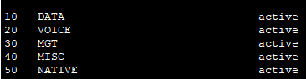

**Part 2: Interface the Ports on the Switch.**

**Step 1: Interface Port Fa0/48 as a Trunk.**

1. Enter the interface for port **Fa0/48** using the **Interface** command.

**Switch(config)#interface fa0/48**

1. Ensure that the **trunk encapsulation** is **dot1Q. (*NOTE* if this results in an error, this step is unnecessary because dot1Q encapsulation is the only available option)**

**Switch(config-if)#switchport trunk encapsulation dot1Q**

1. Change the **Switchport Mode** to **Trunk** so that one port can carry traffic for all the VLANs.

**Switch(config-if)#switchport mode trunk**

1. Change the **Native Trunk** to **VLAN 50.**

**Switch(config-if)#switchport trunk native vlan 50**

1. Exit the interface mode for port **Fa0/48** using the **Exit** command.

**Switch(config-if)#exit**

**Step 2: Interface ports Fa0/1-2**

1. Enter the interface(s) for port(s) **Fa0/1 & Fa0/2** using the **Interface Range** command.

**Switch(config)#interface range fa0/1-2**

1. Turn on power over ethernet (PoE) using the **Power Inline Auto** command.

**Switch(config-if-range)#power inline auto**

1. Disable dynamic trunking on port(s) **Fa0/1 & Fa0/2** using the **Switchport Mode Access** command.

**Switch(config-if-range)#switchport mode access**

1. Change the VLAN that the **Access Port** carries traffic to **VLAN 10**.

**Switch(config-if-range)#switchport access vlan 10**

1. Set **Vlan 20** as the voice VLANusing the **Switchport Voice VLAN** command.

**Switch(config-if-range)#switchport voice vlan 20**

1. Exit the interface range mode for port(s) **Fa0/1 through Fa0/2** using the **Exit** command.

**Switch(config-if-range)#exit**

**Step 3: Interface port(s) Fa0/3-47.**

1. Enter the interface(s) for port(s) **Fa0/3 through Fa0/47** using the **Interface Range** command.

**Switch(config)#interface range fa0/3-47**

1. Set the **Access** to **Vlan 40.**

**Switch(config-if-range)#switchport access vlan 40**

1. Shut down the unused ports using the **Shutdown** command.

**Switch(config-if-range)#shutdown**

1. Exit the interface range mode for port(s) **Fa0/3 - Fa0/47** using the **Exit** command.

**Switch(config-if-range)#exit**

**Step 4: Interface port(s) Gig0/1-4 & save the configuration.**

1. Enter the interface(s) for port(s) **Gig0/1 through Gig0/4** using the **Interface Range** command.

**Switch(config)#interface range gig0/1-4**

1. Set the **Access** to **Vlan 40.**

**Switch(config-if-range)#switchport access vlan 40**

1. Secure the unused ports by shutting them down using the **Shutdown** command.

**Switch(config-if-range)#shutdown**

1. Return to **Privileged EXEC** mode using the **End** command.

**Switch(config-if-range)#end**

1. Change the startup configuration to the current running configuration using the **Copy Run Start** command. Press **Enter** at the prompt.

**Switch#copy run start**

1. Show the running configuration using the **Show Run** command.

**Switch#show run**

1. **FastEthernet0/1 & 0/2** should be set to **Switchport Access VLAN 10,** **Switchport Mode Access,** and set to **Switchport Voice VLAN 20**. **FastEthernet 0/3** - **47 & GigabitEthernet 0/1 – 4** should beset to **Switchport Access VLAN 40** and **Shutdown**.You should see **FastEthernet 0/48** set to **switchport trunk native VLAN 50** and set to **switchport mode Trunk**. **if you had to set the encapsulation method then you will also see **switchport mode Trunk encapsulation dot1Q\*\***

**Step 5: Connect the Switch to the Router**

1. Plug one **RJ-45** end of a **Straight Through Copper Cable** into port **Fe0/48** on the **2960/3560 Switch**.
2. Plug the other **RJ-45** end into port **Fe0/0** on the **1811 Router**.

**Part 3: Interface VLAN Routing**

**Step 1: Console into the Router.**

1. Plug the **RJ-45** terminated end, of the **Console Cable**, into the **Console Port** on the **2811 Router.**

1. Open **Terra Term** on the **PC.**

1. Select **Serial**, open the **drop-down menu**, select the **Router COM Port**, and select **OK.**

**Step 2: Configure Sub Interface Routing for VLAN10 on Port Fa0/0.10.**

1. Enter **Privileged EXEC** mode using the **Enable** command.

**Router>enable**

1. Enter **Terminal Configuration** mode using **Configure Terminal** command.

**Router#configure terminal**

1. Enter the Sub Interface for port **Fa0/0.10** using the **Interface** command.

**Router(config)#int fa0/0.10**

1. Set **Encapsulation** type to **dot1Q.**

**Router(config-subif)#encapsulation dot1Q 10**

1. Assign an **IP address and Subnet Mask** to the Sub Interface.

**Router(config-subif)#ip address 192.168.10.1 255.255.255.0**

1. Exit the Sub Interface with the **Exit** command.

**Router(config-subif)#exit**

**Step 3: Configure Sub Interface Routing for VLAN20 on port Fa0/0.20.**

1. Enter the Sub Interface for port **Fa0/0.20** using the **Interface** command.

**Router(config)#int fa0/0.20**

1. Set **Encapsulation** type to **dot1Q.**

**Router(config-subif)#encapsulation dot1Q 20**

1. Assign an **IP address and Subnet Mask** to the Sub Interface.

**Router(config-subif)#ip address 192.168.20.1 255.255.255.0**

1. Exit the Sub Interface with the **Exit** command.

**Router(config-subif)#exit**

**Step 4: Configure Sub Interface Routing for VLAN50 (trunk) on port Fa0/0.50.**

1. Enter the Sub Interface for port **Fa0/0.50** using the **Interface** command.

**Router(config)#int fa0/0.50**

1. Set **Encapsulation** type to **dot1Q.**

**Router(config-subif)#encapsulation dot1Q 50 native**

1. Exit the Sub Interface with the **Exit** command.

**Router(config-subif)#exit**

**Step 5: Turn on port Fa0/0.**

1. Enter the interface for port **Fa0/0** using the **Interface** command.

**Router(config)#interface fa0/0**

1. Turn on the interface with the **No Shutdown** command.

**Router(config-if)#no shutdown**

1. Exit the interface mode for port **Fa0/0** using the **Exit** command.

**Router(config-if)#exit**

1. Show the running configuration using the **Do Show Run** command.

**Router(config)#do show run**

1. Interface FastEthernet0/0 should no longer be **Shutdown**. Three sub interfaces should show up: **FastEthernet0/0.10**, **FastEthernet0/0.20**, and **FastEthernet0/0.50**. They should be set to **encapsulation dot1Q 10, 20, & 50**. Each sub interface should be assigned an **IP address** and **Subnet Mask.**

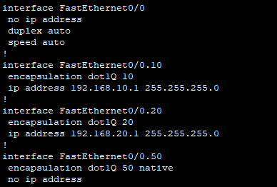

**Part 4: Configure DHCP for the VLANs.**

**Step 1: Excluding addresses for VLAN10 & VLAN20.**

1. Exclude the first **2 addresses** of the **192.168.10.0 Network** using the **Ip dhcp excluded-address** command.

**Router(config)#ip dhcp excluded-address 192.168.10.1 192.168.10.2**

1. Exclude the first **2 addresses** of the **192.168.20.0 Network** using the **Ip dhcp excluded-address** command.

**Router(config)#ip dhcp excluded-address 192.168.20.1 192.168.20.2**

**Step 2: Configuring the IP addresses & subnet masks for VLAN10 and VLAN20.**

1. Enter the DHCP configuration for **DATA10** using the **Ip dhcp pool** command.

**Router(config)#ip dhcp pool DATA10**

1. Give the pool the **192.168.10.0** network address and the **255.255.255.0** subnet mask using the **Network** command.

**Router(dhcp-config)#network 192.168.10.0 255.255.255.0**

1. Assign the default router for this network using the **default-router** command.

**Router(dhcp-config)#default-router 192.168.10.1**

1. Enter the DHCP configuration for **DATA20** using the **Ip dhcp pool** command.

**Router(dhcp-config)#ip dhcp pool VOICE20**

1. Give the pool the **192.168.20.0** network address and the **255.255.255.0** subnet mask using the **Network** command.

**Router(dhcp-config)#network 192.168.20.0 255.255.255.0**

1. Assign the default router for this network using the **default-router** command.

**Router(dhcp-config)#default-router 192.168.20.1**

1. Assign **option 150** to allow VoIP phones to obtain the configuration server address.

**Router(dhcp-config)#option 150 ip 192.168.20.1**

1. Exit DHCP configuration mode using the **Exit** command.

**Router(config-if)#exit**

1. Show the running configuration using the **Do Show Run** command.

**Router(config)#do show run**

1. There should be two DHCP pools. The first should be named **DATA10** with the **Network address: 192.168.10.0**, **Subnet Mask: 255.255.255.0,** and **Default Router: 192.168.10.1**. The second should be named **VOICE20** with the network address of **192.168.20.0**, **Subnet Mask: 255.255.255.0,** and **Default Router: 192.168.20.1.** The first two addresses of each network should be excluded.

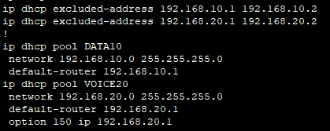

**Part 5: Configure Telephony Services.**

**Step 1: Configure the Directory for each Phone.**

1. Enter **Telephony Configuration** mode using the **Telephony-Services** command.

**Router(config)#telephony-service**

1. Assign a telephony source **Ip address** and **Port #.**

**Router(config-telephony)#ip source-address 192.168.20.1 port 2000**

1. Assign a maximum number of directory entries using the **max-dn** command.

**Router(config-telephony)#max-dn 2**

1. Assign a maximum number of ephones using the **max-ephones** command.

**Router(config-telephony)#max-ephones 2**

**Step 2: Configure a number for each ephone.**

1. Assign a number to the first ephone in the directory.

**Router(config-telephony)#ephone-dn 1**

**Router(config-ephone-dn)#number 1010**

1. Assign a number to the second ephone in the directory.

**Router(config-ephone-dn)#ephone-dn 2**

**Router(config-ephone-dn)#number 1020**

1. Exit telephony services configuration mode using the **Exit** command.

**Router(config-ephone-dn)#exit**

**Part 6: Configure Ephones 1 & 2**

**Step 1: Configure ephone 1’s MAC address, type, and button number**

1. Enter ephone 1’s configuration mode by entering **ephone 1** at the terminal configuration mode.

**Router(config)#ephone 1**

1. Enter the phone’s **MAC address** located on the **Rear** of the phone.

**Router(config-ephone)#mac-address xxxx.xxxx.xxxx**

1. Enter the phone type **7945** and button number **1:1.**

**Router(config-ephone)#type 7945**

**Router(config-ephone)#button 1:1**

**Step 2: Configure ephone 2’s MAC address, type, and button number.**

1. Enter ephone 2’s configuration mode by entering **ephone 2**.

**Router(config-ephone)#ephone 2**

1. Enter the phone’s **MAC address** located in the same spot on the **Rear** of the other phone.

**Router(config-ephone)#mac-address xxxx.xxxx.xxxx**

1. Enter the phone type **7945** and button number **1:2**.

**Router(config-ephone)#type 7945**

**Router(config-ephone)#button 1:2**

1. Return to user EXEC mode by entering the **End** command

**Router(config-ephone)#end**

**Step 3: Save the Configuration & Connect the IP Phones to the Switch.**

1. Change the startup configuration to the current running configuration using the **Copy Run Start** command.

**Router#copy run start**

1. Show the running configuration using the **Show Run** command.

**Router#show run**

1. Under **Telephony-Service**, the **IP Source-Address** should be **192.168.20.1** on **Port 2000.** **Ephone 1** should be in the directory as **number 1010** and **Ephone 2** should be in the directory as **number 1020**. **Ephones 1 & 2** should have their **MAC Addresses** listed and be listed as **Type 7945.** Ephone 1 should be button 1:1 and ephone 2 should be button 1:2.

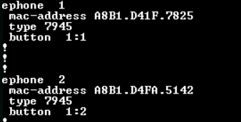

1. Plug a **Straight Through Copper Cable** into the **RJ-45 Switch port** on each **IP phone**. Graphical user interface, diagram

   Description automatically generated
2. Plug the other end of each **Straight Through Copper Cable** into either port **fa0/1** or port **fa0/2** on the **Switch**.

**Step 4: Verify Phone Connectivity**

1. Pick up a phone and dial the number not assigned to that phone. (**1010** or **1020**)

1. The other phone should ring.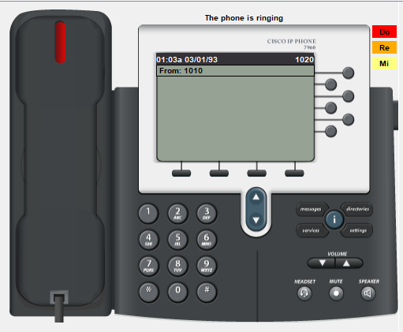

**Part 7: Configure PC Hosts**

**Step 1: Enable DHCP on the PCs**

1. Click the **windows** icon on the taskbar, select **settings**

1. Select **Network & Internet**

1. Select Ethernet **Properties**, Select **Edit** IP settings, Select **DHCP,** and select **Save**.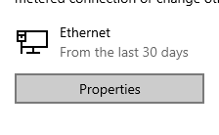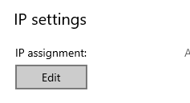

**Step 2: Connect the PCs to the Phone**

1. Plug the **RJ-45** terminated end of **Straight Through Copper Cable** into the **PC Port** on each **IP phone**.

1. Plug the other **RJ-45** end into the **Ethernet port** on each **PC**.

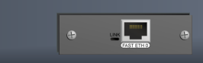

**Step 3: Verify PC connectivity using the ping utility.**

1. In the Windows Search Bar type **Command Prompt** and open the **Best Match.**

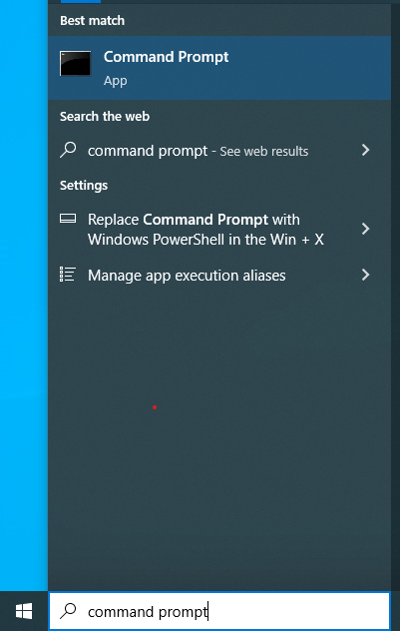

1. Type “ping 192.168.10.X” and press enter (X is the IP address of the other PC) Text

   Description automatically generated
2. View successful pings

